26 December 2021
Comrades,
I hope everyone had a great time during the Christmas holiday. We are nearing the end of another year and entering into the second half of the current 2021-2022 term.
As we look forward to the next year, I ask every one of you to review our Post’s activities and events conducted during 2021. We were met with the daunting limitations and restrictions of COVID-19, but we persevered. The post accomplished most of our goals and community outreach projects. My thanks and appreciation go to all who made this possible.
We have several more goals and responsibilities yet to meet before the end of this term. I ask all our members to attend our monthly Post meetings in person if possible and on virtual video link if not. Our meeting times and video link information is posted on our website, vfw12074.org, with reminders posted on the Post’s Facebook, LINE and Google Group Forum social media platforms.
Your attendance at the Post’s meetings will ensure you’re kept current on all the Post’s activities and projects. Please remember you are welcome and encouraged to take part in any or all of these events. We are a volunteer organization and cannot succeed without your involvement.
One of the important issues facing the Post is nominations for the officers’ positions in March and election in April. We have a wealth of experience, capabilities and assets in the ranks of our members. I ask each one of our members to take a personal assessment of their skills and knowledge to see how you can provide service to the Post. Some of you have the leadership and management skills to fill the Commander, Senior Vice Commander or Junior Vice Commander roles. Others may have the organizational and bookkeeping skills to become our Quartermaster or Trustee. Perhaps you have background with VA information and can serve as the Post Service Officer assisting our local veterans. Seek out a role you’re equipped to serve and volunteer.
There are many opportunities to serve in our organization, but these will go unfulfilled if we don’t step up to the challenge. To paraphrase a quote from a past US President, “Ask not what the VFW Post can do for you, but what you can do for the VFW Post”.
I wish you all a good, happy and healthy new Year,
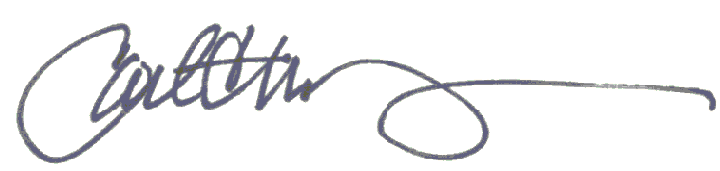
Carl Manchester
Past Commander 2019-2021
VFW Post 12074
Chiang Mai, Thailand

